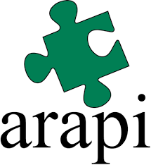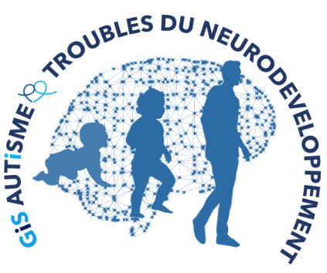

ARAPI’s Autumn University : Networks from brain to social life.

ARAPI/ GIS Autism and NTDs present : Young Researchers workshop
Episode #1 – From the brain to the behaviour.

October 5, 2021 – 100% digital day

From 2021, the traditional Autumn University of the ARAPI is organized with the support of the GIS (Group of Scientific Interest Autism and Neuro-Development Disorders). This GIS is in charge of the coordination of a multidisciplinary research network connected to the needs of the people concerned and their families. A year after its creation, this GIS brings together nearly 100 labelled research teams throughout France and now extends its expertise and actions to the European level.

Before the Autumn University of the ARAPI, due to be held from October 3 to 7, 2022 in the Croisic, the ARAPI and the GIS invite relevant parties – researchers, clinicians, associations and families - to a remote scientific workshop on October 5, 2021.

This “Episode #1” 100% digital will focus on the theme “Neuro-Developmental Disorders: from the brain to the behaviour”. Theses scientific communications will be based on the conferences of two outstanding researchers, scientific leaders of the GIS :

- Professor Ghislaine Dehaene (NeuroSpin, Paris-Saclay), pediatrician and neuroscientist, specialized in typical development and children’s learning. Her work in imaging and electrophysiology has led to decisive advances in the understanding of the neural networks dynamics, involved in infant’s learning.

- Professor Mohamed Jaber (LNEC, Poitiers), neuroscientist, specialized in motor impairment associated with Neuro-Developmental Disorders, whose recent researches have provided innovative results about the role of basal ganglia and cerebellum in Autism Spectrum Disorders.

This day will be an opportunity for young researchers and selected young clinicians to present research work resulting from international collaborations and nourished by the participation of the persons concerned and their families.

While waiting for the opportunity to meet up in a convivial setting, this "100% digital" day will enable constructive exchanges between high-level scientific actors, caregivers, associations, affected persons and families, in direct contact with the realities of the field.

