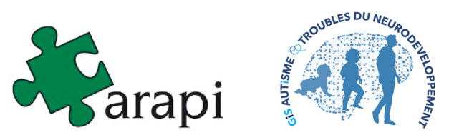

Networks from the brain to social life
episode 1: from brain to behaviour

Remote Scientific Day ARAPI / GIS Autism and NDDs : CALL FOR PAPERS

5 October 2021

The traditional Autumn University of the ARAPI has a new scope. Indeed, it is co-organised with the Groupement d'Intérêt Scientifique Autisme et Troubles du Neuro-Développement (GIS Autisme et TND). This GIS ensures the coordination of a multidisciplinary research network connected to the needs of the people concerned and their families. The GIS brings together nearly 100 accredited research teams throughout France and is now extending its expertise and actions to the European level. Thus, the GIS is currently structuring its work to encourage the emergence of international collaborative initiatives.

In the context of COVID 2019, the Autumn University is now divided into two episodes. The first will take place on Tuesday 5 October 2021 in the form of a remote scientific day. The second episode could see the revival of the classic meeting in Le Croisic for a week of exchanges and scientific work from 3 to 7 October 2022.

In the context of the distance learning day on 5 October 2021, this call for papers concerns two events of the programme :
- The GIS Young Researchers Session including oral communications
- The Poster Session

The proposal for a paper (oral or poster) must report on a study for which the full research procedure has been carried out, i.e. data have been collected, processed and interpreted, allowing hypotheses to be answered and conclusions and perspectives to be drawn. Proposals for partial research reports or research that is in its early stages and does not allow for the presentation of results will not be considered. Both basic and clinical research projects will be considered.

This call for papers is primarily aimed at young researchers (scientists or clinicians / PhD students, post-doctoral fellows, tenured researchers up to 3 years after their tenure).
Eligible for the 3 oral presentations at the "GIS session" are :
- young researchers and/or young clinicians who are part of a labelled research team belonging to the GIS at the time of the remote scientific day.

You can join the network at this address : | https://tinyurl.com/yybuhhgs | 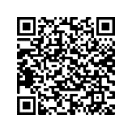

- Proposals will fall, at least in part, under one of the following themes :
  - in the fields of ASD/NDT
  - in the "neural networks" theme
  - in the framework of an international collaboration.
  - in the framework of a "participatory research".

Posters must be in the field of developmental disorders, including ASD.

Your paper proposal, formulated in French or English, should be submitted online using the form available at this address :

https://tinyurl.com/y4hucyox | 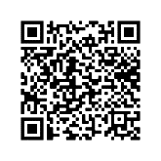

A young researcher "prize" will be awarded to the best paper and will lead to an invitation for an oral communication in the general programme of the Autumn University 2022 with free participation in the whole event (transport, accommodation, catering and registration).
Contact for any information request :
com.ua.arapi.gis.2021@gmail.com

